***OWAIS UDDIN AHMED***  ***LAB # 3***

***2018-CS-136***

***C***

Q1) Airport check-in and security screening business model

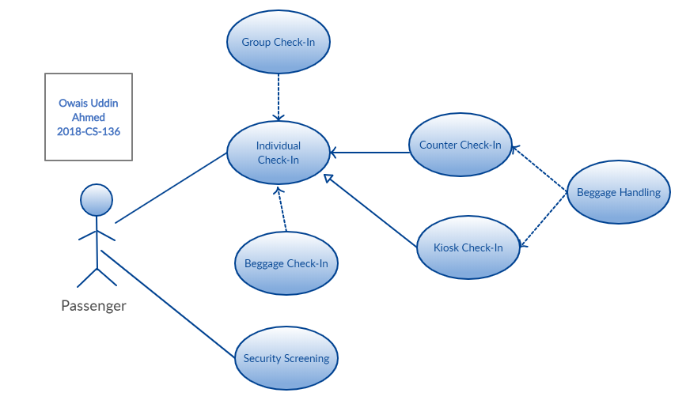

Q2) restaurant business model use case diagram

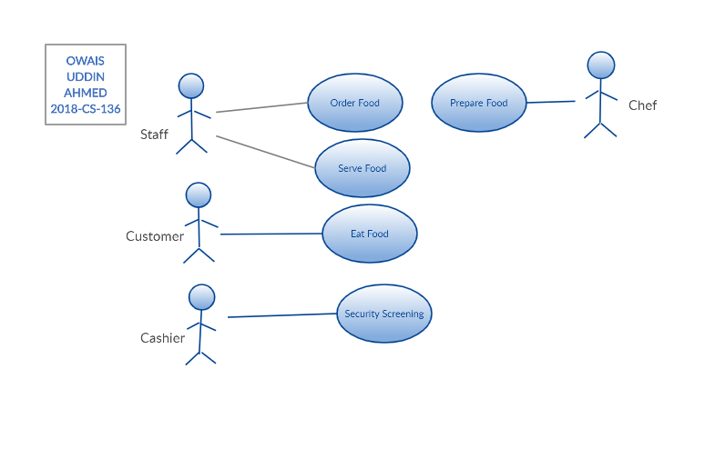

Q3) Ticket vending machine

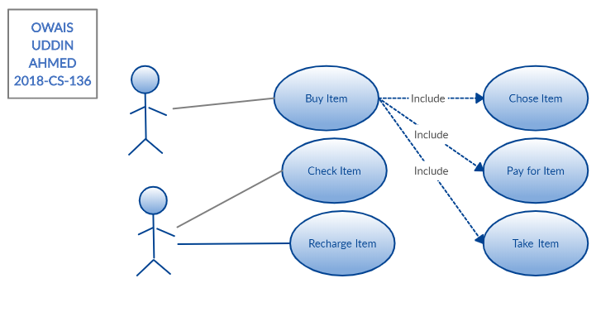

Q4) Bank ATM UML use case diagrams example

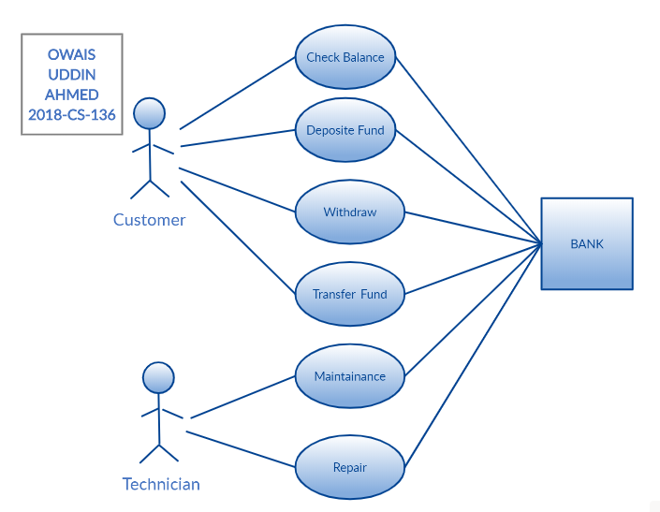

Q5) Point of sales (POS) terminal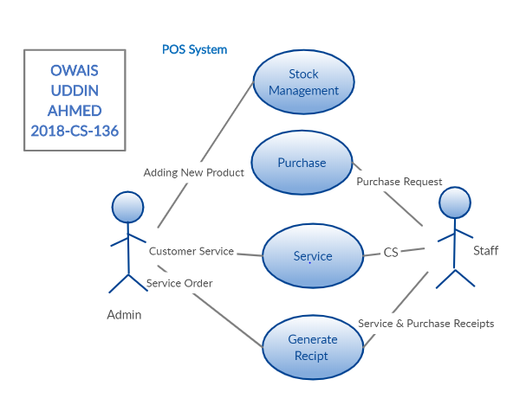

Q6) e-Library online public access catalog (OPAC) 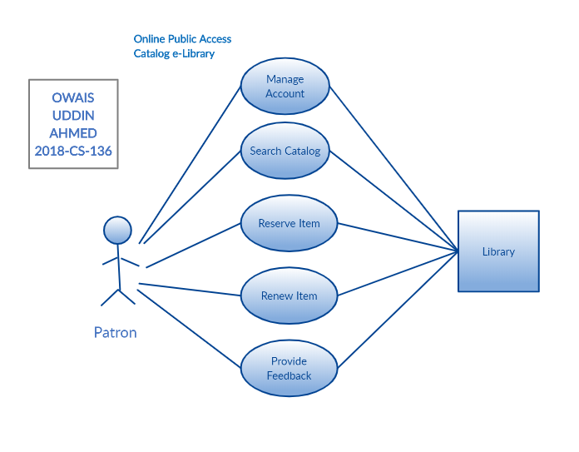

Q7) Online shopping use case diagram

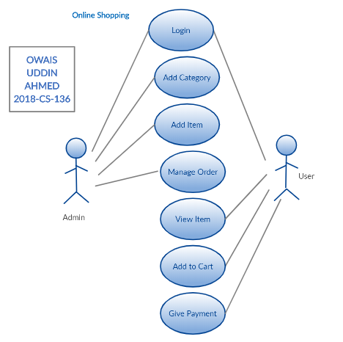

Q8) Website administration

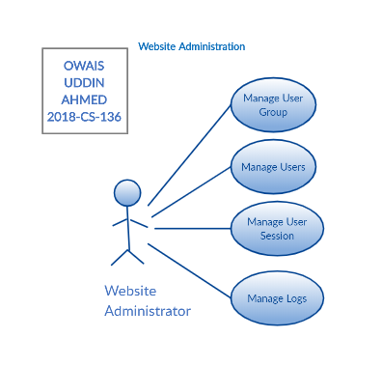

Q9) Hospital Management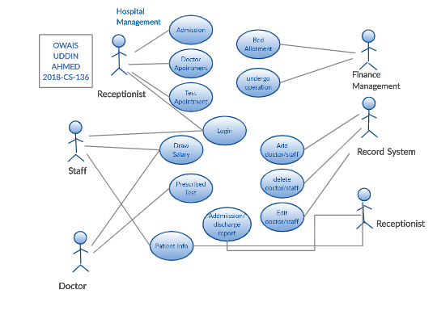

Q 10) Radiology diagnostic reporting UML use case diagram

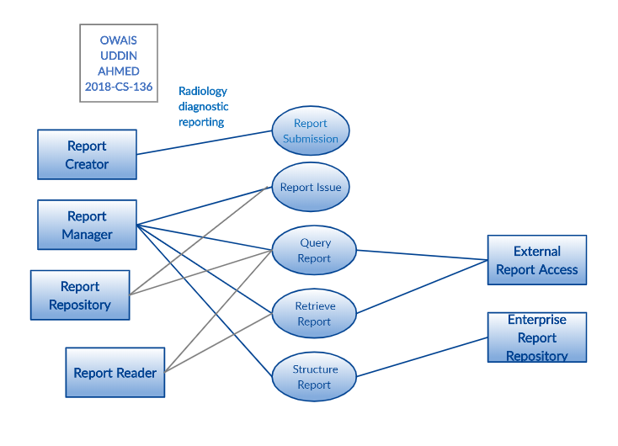

**Exercise**

1. Design a UML diagram for a centralized hotel reservation system which is working online, hotel desktop application and a customized application for travel agents.

